

**Uncertain times**

Speech given by

Ben Broadbent, Deputy Governor Monetary Policy, Bank of England

At the Wall Street Journal, The News Building, London 5 October 2016

I would like to thank my fellow MPC members and other Bank colleagues for their helpful comments. The views expressed are my own and do not necessarily reflect those of the Bank of England or other members of the Monetary Policy Committee.

Before August, the UK’s official interest rate had been held at ½% for over seven years, the longest period of unchanged rates since 1950. No-one on the current MPC was on the Committee when rates were previously changed, in early 2009; indeed there are children now at primary school who weren’t even alive at the time. So although the August *Inflation Report* gave a pretty full account of the reasons for the MPC’s decision it wouldn’t do any harm to expand on these things a little further. That’s what I plan to do today, focussing on two areas.

The first involves one of the main reasons for the revised – and weaker – economic projections we made in the August *Inflation Report* and the policy easing that accompanied it. This was not a judgement about the ultimate economic effects of the UK’s exit from the EU, not least because we are unlikely to know, for quite some time, what that will entail.

Instead, the key judgement for the MPC was that this uncertainty would itself weigh on demand and

investment spending in particular. So I’ll say something about why, in general, longer-term capital spending is particularly sensitive to uncertainty; why consumption (and faster-depreciating types of capital) are less affected; and why housing might, in this respect, be something of a grey area.

The second issue is the interaction between monetary policy, bond yields and the financial position of pension funds. Not for the first time, the MPC’s decision to ease policy has been criticised by some for raising the deficits of defined-benefit (DB) pension funds. The liabilities of these funds – fixed future payouts to the pension beneficiaries – are discounted by a longer-term bond yield. So all else equal, a fall in that yield raises the present-value cost of funding these payouts.

But the key phrase is “all else equal”. The overall impact of monetary easing on DB schemes – and on the companies who run them – depends on what it does to the prices of their assets, not just their liabilities; what it does to the wider economy; and the composition of other parts of the companies’ balance sheets.

Much of this has been pointed out before, including in a speech in 2012 by my predecessor Charlie Bean. But I will dwell on one particular point: what makes life difficult for these funds is not so much the fall in bond yields *per se* but one that isn’t accompanied by a fall in yields (rise in prices) on other, riskier securities they hold as assets. That’s precisely what has happened in recent years: on days that long-term real interest rates have fallen, equity prices have declined. More often than not, in other words, the yields on gilts and equities have gone in opposite directions and, over time, the gap between those yields has widened considerably.

Since an independent easing of monetary policy tends at the margin to depress yields (raise prices) of all assets – and that’s precisely what you observe if you focus specifically on those episodes – it’s hard to believe that policy shocks are the main reason for the divergence between bonds and equities that underlies

the rise in pension deficits. More likely candidates are growing pessimism about future economic growth, across the world, and the perception that risks around that lower central path are skewed to the downside. This is part of the wider point that, in large part, central banks have been accommodating a long, drawn-out decline in the neutral real rate of interest. The decline in policy rates is a symptom not a cause of the forces shaping the global economy. And if, within the criticism, there’s an implicit assumption that there’s an alternative universe in which everything else stays the same – real economic growth, real incomes and risky asset prices – but real interest rates are materially higher, then I’m not sure that’s right. I don’t think such a universe exists.

# Uncertainty and investment

Let me start with the August forecast, and the downward revision to investment in particular (Chart 1).

It is often said that because consumer spending accounts for the lion’s share of aggregate demand - 65% of it in 2015, compared with 10% for business investment – the economic cycle depends mostly on household consumption.

But investment is far more volatile than consumption (Charts 2 plots their growth rates, in annual data, since 18351). Allowing for this, their arithmetic contributions to aggregate demand growth are equally variable.

There’s no reason to suppose investment is any less important than consumption in driving economic cycles. In fact, in many cycles, including during the financial crisis, it appears to move ahead of consumption.

# Chart 1: Business investment revised down in August

**Chart 2: Investment far more volatile than consumption**

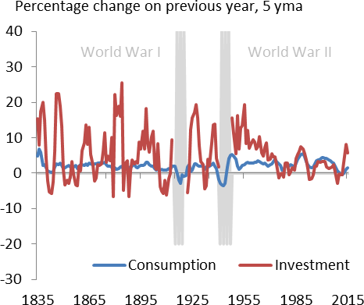Percent, 4qma Standard deviations from mean

.

30 -5



Aug IR

May IR

Business investment (LHS)

UK uncertainty indicator (RHS)

20

-2

10

0 1

-10

4

-20

1985 1990 1995 2000 2005 2010 2015

Source: ONS and Bank of England calculations

Source: ONS and Bank of England calculations

1. I’ve excluded the World War periods because investment growth was so volatile it would have dominated the graph. During World War II investment fell almost to nothing. In 1945 this remained quite low, so in 1946 its growth rate jumped to 1,894%!

One obvious reason for the volatility of investment is the natural gearing in such decisions. The flow of investment spending is much smaller than the existing stock of capital2. So small changes in the second can require big moves in the first. Suppose, for example, you regularly spend a steady but relatively small amount on repairs and maintenance for your house – something that counts as investment – and then decide, in one particular year, that you want to build an extension. This will have a much bigger proportionate impact on the flow of your capital spending than on the size of the building (the “capital stock”). It will also mean your investment spending is far more volatile, from one year to the next, than your consumption.

Similarly, small shifts in a firm’s desired capital stock require much bigger proportionate changes in investment.

But this gearing effect isn’t the only reason. Another important consideration is that many investment projects are – at least to some degree – irreversible. Once made, they can’t be easily or costlessly unmade. (Removing an extension to a house might cost as much as building the thing in the first place.) So, if there’s any uncertainty about future returns – if you know that you might come to regret the decision – you have to be extra sure before you actually take the plunge. It’s no longer enough that the expected income from the project covers the initial cost. It has to do so by a potentially wide margin, a margin economists call the

“option value of waiting3”.

There are lots of decisions in life that have these characteristics. Moving house, taking a new job, even getting married – these are all things than can be delayed but cannot be easily reversed. And it makes intuitive sense that, in the presence of uncertainty, there’s value in keeping one’s options open4.

How much might that option be worth, when it comes to investment decisions? Quite a bit, it turns out. Based on a simple stylised model, Chart 4 plots the additional hurdle required of irreversible investments against the variability of annual growth in the returns they generate. For individual firms, earnings vary considerably from one year to the next – the standard deviation of annual growth has on average been as much as 40% points (Chart 3). If this is a guide to the uncertainty firms feel about returns on new investments then, on the basis of the model in Chart 4, you might expect an additional hurdle of 10% points or more, over and above the normal cost of funding.

1. In steady state, the ratio of capital to investment is 1/(g+δ), where g is trend growth and δ is the rate of depreciation. In advanced economies, and recognising that a substantial proportion of capital is the value of land (which doesn’t depreciate) g+δ is unlikely to be more than 7% - so the value of the capital stock is generally more than 15 times the annual rate of investment. In 2015, according to official ONS estimates, the ratio was 23.
2. Financial options are instruments that give the owner the right to buy or sell an underlying security at a fixed, so-called “strike” price.

When the security’s spot price rises above the strike an option to buy is said to be “in the money”. But that doesn’t mean it’s rational to exercise the option straightaway, because there’s a chance the spot price could rise further. The more volatile the series, the greater that chance and the more valuable the option. In just the same way, it’s not enough that the option to make an irreversible investment project be expected to cover its financial cost – it has to cover the value of waiting, and that value is higher the more uncertain the resulting stream of income. Those familiar with such things will recognise Chart 4 as the Black-Scholes formula for pricing financial options (Dixit and Pindyck (1994)).

1. “Married in haste”, said Congreve, ”we may repent at leisure”. See Park (1993) for an economic interpretation of this dictum, framed in

terms of the option value of waiting.

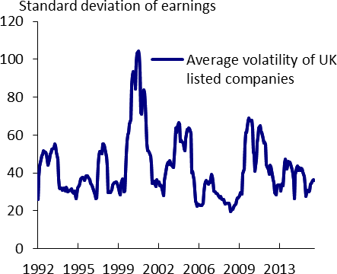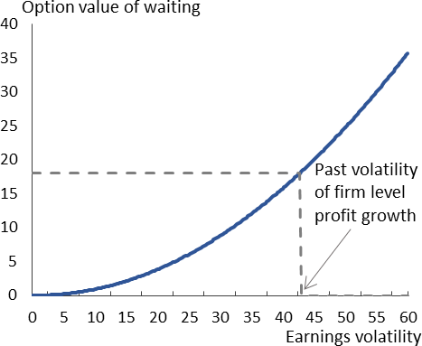If that seems steep, it chimes with what we often hear on our regular company visits. Last year, I went to see a successful SME that was thinking about an acquisition. The firm was in good financial shape – it had very little debt and a fair amount of low-yielding cash on its balance sheet. But it was nonetheless reluctant to make the investment without a prospective rate of return of at least 15%. This isn’t that unusual – I’ve heard similar things from several companies.

|  |  |
| --- | --- |
| **Chart 3: Corporate earnings very volatile** | **Chart 4: Hurdle rate for irreversible investment rises steeply with uncertainty** |
| Note: 12-month rolling window standard deviations of annua growth rates of earnings of all companies currently in the FTSE All-Share index.  Source: Thomson Reuters Datastream | l |

The importance of uncertainty is also borne out in aggregate data – for investment, overall economic activity and even some aspects of employment. Charts 5-7 set out some of the relevant numbers for the UK. They all use an index of uncertainty developed by Bank economists, based on a range of variables, including media references, options prices and the dispersion of economic forecasts5.

1. The composition of this index is standard in the literature. But it’s always good to know more. To that end, and in collaboration with H M Treasury and a group of academic economists, the Bank is setting up new Decision Maker Panel of senior executives from a wide range of British companies. Each month the panel members will provide information on how business conditions are changing and, in particular, about the weight they attach to different possible outcomes for investment, sales, employment, costs, prices and margins. In this way we hope to monitor in a timely manner changes in the uncertainty business is facing and how they are reacting to it. This will add to the information we already collect from surveys, official sources and the Bank’s Agency network

|  |  |
| --- | --- |
| **Chart 5: Uncertainty indicator well correlated with GDP growth** | **Chart 6: Better correlated with investment than consumption** |
| Source: ONS and Bank of England calculations | Source: ONS and Bank of England calculations |
| **Chart 7: Rising uncertainty tends to shift new hiring towards temporary jobs** | The first two speak for themselves: aggregate GDP growth is strongly correlated with uncertainty; on the demand side, the share of business investment is more sensitive than that of consumer spending6.  The fourth is interesting. Although employment decisions are more easily reversed than most capital spending, permanent appointments do involve at least some degree of commitment and therefore might be susceptible to changes in uncertainty. The data seem to bear this out. Chart 7 plots the change in the uncertainty measure against the ratio of temporary to permanent job hires (as measured by the REC job market survey). The correlation is clear, including in the  most recent data. |
| Source: REC survey, ONS and Bank of England calculations |

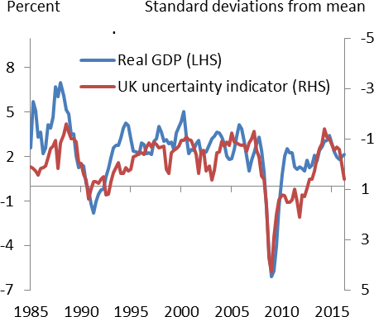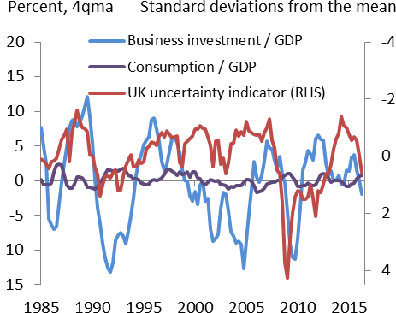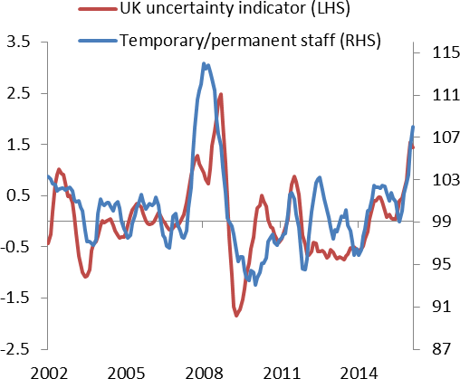

1. Charts 5-7 display the bare correlations with uncertainty and don’t necessarily tell you about causation – it’s quite possible that weaker growth increases uncertainty about the future. But even after you attempt to control for this reverse effect, the impact of exogenous changes in uncertainty still appear very significant. See Haddow et al. (2013) and also Bloom (2009)

# Specific effects of uncertainty about the impact of EU exit

Let me make a few additional points that may be particularly relevant in the current context:

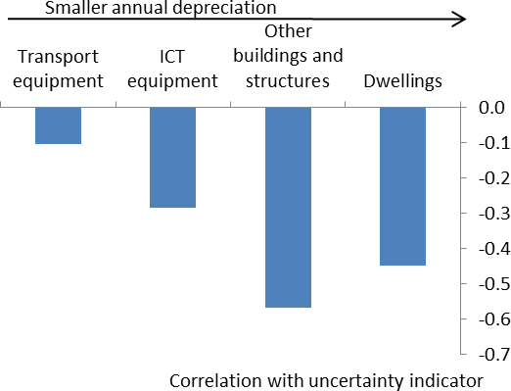First, this uncertainty effect applies to all sunk-cost decisions about the future – in particular, it would make firms more hesitant about scrapping capacity, not just adding to it. That’s not to say that such decisions are never taken. If a firm gets genuine news that makes a particular activity unprofitable, it may well come to the point where it has to withdraw, writing off the capacity involved. But uncertainty *per se* raises the bar for all such decisions, disinvestment and new investment alike. So a lack of clarity about the UK’s future trading relationships needn’t result in visible, headline-grabbing closures of productive capacity. The effect is likely to be more insidious: decisions to expand, that might otherwise have been taken, are delayed.

|  |  |
| --- | --- |
| **Chart 8: Correlation with uncertainty is higher for slower-lived investments** | Second, one would also expect the impact to be more acute for long-lived (low-depreciation) investments – buildings more than IT equipment, for example. Intuitively, this is because their consequences last longer – the slower the rate of depreciation on a particular investment, the less like consumption it becomes. In the data, the correlation with uncertainty does seem to be higher for longer-lived investments (Chart 8). And if this is true in general, I think it’s particularly likely to be the case in this instance. The additional uncertainty brought about by the referendum involves the UK’s trading relationships once it formally leaves the EU. That is likely to be some way off – two years after  the relevant treaty article is triggered. |
| Source: ONS |

And by that time, much of the economic value in high-depreciating items like cars and computers will already have been exhausted. So a lack of clarity about events beyond that date won’t be as relevant as it is for longer-lived capital. As formal exit approaches the higher-depreciating items, and a greater share of

investment, will become affected as well. That said, the shape of the UK’s trading arrangements may also become clearer during that time.

Third, I should re-iterate that what we’re talking about here is a pure increase in uncertainty, not a change in the central expectation firms have about investment returns. The range of outcomes doesn’t have to shift downwards for firms to delay some projects, it only has to widen. But if that range were to shift, this would obviously matter as well. One thing this implies is that the effect of resolving uncertainty depends on how, and in which direction, the resolution occurs. If you collapse the range of alternatives to the worst possible outcome – now you know for sure that a project isn’t worth pursuing – that would obviously hit investment,

despite the drop in uncertainty. If it keeps open the possibility of better outcomes a lack of clarity may sometimes be worth putting up with.

# Monetary policy and DB pension schemes

Let me turn now to my second topic, the interaction between low bond yields, QE and the financial position of defined benefit (DB) pension schemes.

These funds do exactly what they say on the tin: they promise their beneficiaries a fixed future payout, not unlike the coupon on a government bond. That’s why they’re obliged to discount these liabilities by the longer-term bond yield. That, in turn, means the present-value cost of those liabilities goes up when the bond yield falls. And because easier monetary policy tends in the first instance to do precisely that – to depress yields – central banks have been criticised in recent years for worsening the financial position of such funds. Since its decision to ease monetary policy in August, both by lowering Bank Rate and expanding its asset purchases, the MPC has again encountered this concern.

Just as this point isn’t new, nor is what I’ll say in response. The main thing to understand is that, even if domestic monetary policy has some bearing on real interest rates, at least for a while, it is not their ultimate determinant. In the end real rates are driven to their natural level by deeper economic forces. The policy rate is but one expression of those forces.

|  |  |
| --- | --- |
| **Chart 9: Long term real interest rates are determined globally** | With open capital markets, and for a small economy like the UK, one can actually go further than that: it’s unlikely that any domestic factor, whether monetary policy or anything else, can be the predominant influence on longer-term real interest rates, as these are determined globally. Consistent with this, longer- term real interest rates are tightly correlated internationally (Chart 9). In particular, they all share the same downward trend over the past couple of decades. With inflation relatively stable in all these countries, it’s hard to believe central banks were doing much else than simply following a similar decline in the neutral rate of interest – the level consistent with stable inflation. It’s also hard to believe that, whatever its cause, UK real rates could  have escaped this decline. |
| Sources: King and Low (2014), Rachel & Smith (2015), Bloomberg, Consensus Economics, IMF, Thomson Reuters Datastream.7 |

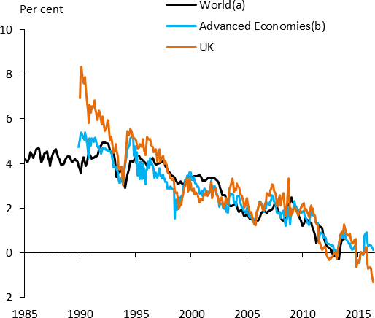As I say these points have been made before8. And in making them again, I don’t want to underplay the potential significance of pension fund deficits. The MPC is, and must remain, watchful for any sign that higher deficits are pushing up funding costs for companies exposed to them or in any other way inhibiting corporate investment. Nor do I want to pretend that monetary policy has no bearing on these deficits.

But it’s important to get any such effects in context and, in this respect, I do want to make one particular point. What really matters here is not, in and of itself, the drop in the yield on bonds (i.e. the rise in their price), but one that’s not been matched by a similar appreciation in pension funds’ assets, equities in particular. However, an independent easing in monetary policy tends to push up the prices of all assets, equities as well as bonds. So it seems an unlikely candidate for the divergence that has been the key problem for DB schemes.

Let me explain this a little further. Though their liabilities are discounted purely by the yield on bonds, pension funds tend to hold a broader-based set of assets. In particular, they hold significant quantities of equities. In general, that may well be a reasonable strategy. As the riskier asset, equities have tended historically to outperform bonds. The extent of the outperformance, the so-called “equity risk premium”, is

1. (a) Taken from King and Low (2014). Shows the average 10-year yield of inflation-linked bonds in the G7 countries (excluding Italy) over the period 1985-2013. Between 1985 and 1992 only data for the UK are available. (b) An update of the estimates in Rachel & Smith (2015). This is calculated as the nominal yield on 10-year sovereign bonds minus 1-year ahead inflation expectations from Consensus Economies. Figures have been GDP-weighted together for 20 advanced economies .
2. The notion that the neutral real rate had been falling goes back well over a decade. The more recent references include King and Low

(2014), Miles (2014), Broadbent (2014), Rachel and Smith (2015) and Bernanke (2015).

generally reckoned to be several percentage points a year. On that basis, and within reason, a fund could tolerate a deficit and still afford to meet its obligations, simply through holding higher-yielding (if riskier) assets than those used to discount its liabilities. Furthermore, if equities and bonds move in a similar direction – as, for example, they did through much of the 1990s (Chart 10) – then those deficits should also be relatively stable. The fund would be hedged against factors that push equities and bonds in the same direction9.

But over the past decade or so, equities and bonds have been negatively correlated (Chart 11 is a scatter plot of their daily changes since 2002). More to the point, the general tendency has been for bonds to do well

– for yields to decline – and equities poorly. It’s this outperformance of the safe asset, highly unusual over such a sustained period, that has been the main problem for DB schemes.

|  |  |
| --- | --- |
| **Chart 10: Equity and bond yields moved together during the 1990s** | **Chart 11: Negatively correlated in recent years** |
| Source: Thomson Reuters Datastream | Source: Thomson Reuters Datastream |

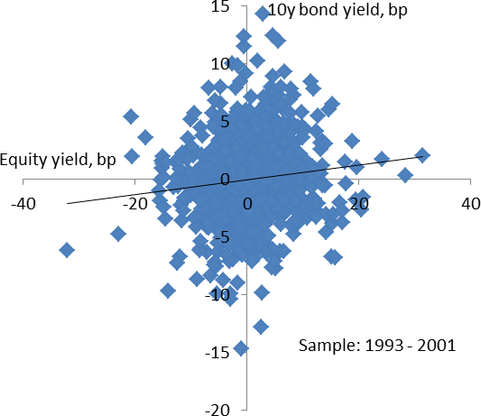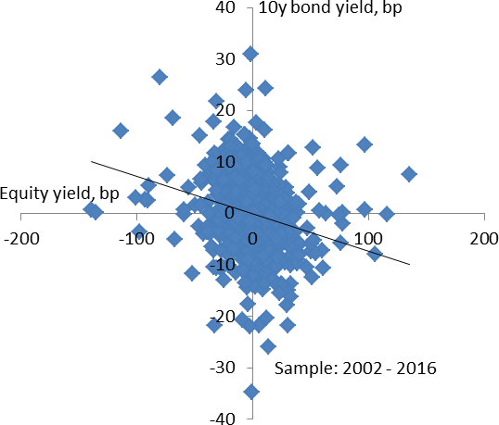What might have caused this? In principle, the gap between the yields on equities and bonds depends positively on the risk premium and negatively on expected growth. So you’d expect this divergent pattern if investors revise down their central expectation of future growth, or if they see more risks (particularly downside risks) around that path. Collectively, you might refer to the sorts of things that benefit bonds and penalise equities as “pessimism” shocks. As I attempted to explain in a talk a couple of years ago, a rising downside skew to the perceived prospects for global growth could help to explain not just the divergence in yields but more specifically why it’s occurred via a decline in the real interest rate (Chart 12).

1. This is true if you think of the deficit in proportionate terms (i.e. relative to the value of the fund). It’s also true in absolute terms if a fund is in balance to begin with. It’s not true, however, of the absolute value of the deficit for a fund that begins in deficit. In that case, and measured in absolute terms, deficits would grow in response to a uniform rise in all prices. However, the bulk of the rise in deficits has arisen not from this source but from the underperformance of risky asset prices I refer to in the text.

One can’t say for sure why pessimism has grown, though a long period of weak productivity growth, across the developed world, can’t have helped. Nor is it hard to see sources of downside risk. But one thing that’s unlikely to have been the primary cause of this divergence is monetary policy. That’s because an independent easing in policy – that part of it unrelated to declines in the neutral interest rate – tends to push up all prices of all assets, risky as well as risk-free. That was certainly the case after the MPC’s decision in

August, just as it was when the Committee first undertook QE in 2009 (Chart 13). As Charlie Bean explained in 2012, the direct impact of QE on pension funds – particularly those who were in balance on the eve of the financial crisis – therefore looks to have been relatively small10. Indeed if the MPC and other monetary

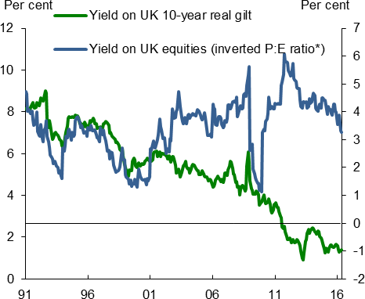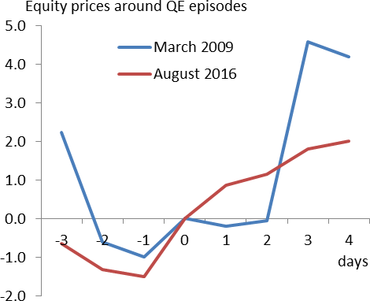authorities hadn’t eased policy – if they had failed to accommodate the forces pushing down on the neutral real rate – the performance of the economy and equity markets, and the long-term prospects for pension funds, would probably have been worse.

|  |  |
| --- | --- |
| **Chart 12:Risky assets have under-performed** | **Chart 13: Easier monetary policy supports prices of risky as well as risk-free assets** |
| Note: * Equity yields have been adjusted for leverage. Source: Thomson Reuters Datastream | Source: Thomson Reuters Datastream |

# Concluding remarks

This talk has been all about rational responses to higher uncertainty: how it raises the bar for decisions that are costly to reverse and – particularly when skewed towards downside risks – how it widens the gap between yields on risky and risk-free securities, contributing to the decline in the neutral real rate of interest and worsening the accounting deficits of pension funds.

1. As Charlie explained, QE probably has acted to raise the absolute deficit of schemes that were under-funded to begin with. But the more important problem has been the under-performance of risky assets (see also footnote 9).

But human instinct in this area isn’t always so rational. We’re prone to over-interpret noisy events, seeing structure and determination when, very often, there isn’t any11.

If this is a general weakness, it’s no less evident in the wake of the referendum. Every bit of economic data is scrutinised for the impact of the vote to leave the EU. If it’s more positive than expected immediately beforehand, this is said to confirm the wisdom of the decision; a negative surprise and we’re meant to conclude it was a bad idea.

This is, to say the least, a stretch. It’s not simply that it’s early days, though that’s certainty the case. (We haven’t even begun to talk about the terms of EU withdrawal as yet, let alone those of any new arrangements.) It’s also that many economic indicators are in general very noisy, even at the best of times.

Retail sales, for example, are estimated to have fallen by 0.2% between July and August. Is this meaningful? Not really. The index is extremely volatile – the average monthly change in retail sales volumes is over a percentage point – and poorly correlated with quarterly GDP, even with consumption growth specifically.

Looking at a broad range of indicators, there’s certainly nothing I can see to disturb the MPC’s view in August that consumer spending will be relatively unperturbed by the referendum result, and that it will continue to grow in line with household income. (Real household income growth is itself likely to decline slightly, as the benefit of falling commodity prices fades, but that’s a separate effect, one that would’ve occurred whatever the result of the referendum.)

Business investment we expect to be more affected, for the reasons I’ve gone through today. But this too is a volatile series, one that’s also subject to significant revision: almost half the mature and early estimates of quarterly business investment growth actually have different signs. So if an early estimate points to a very large move, or if you see a trend over several quarters, it’s worth paying attention to. But early on, it’s as important to look at investment surveys as it is the official estimates. These too bear out the broad shape of the MPC’s August forecast (Chart 14). And as I’ve explained today, that shape has nothing to do with the longer-term consequences of EU exit, depending much more on the uncertainty about those consequences. All that said, there’s little doubt that the economy has performed better than surveys suggested immediately after the referendum and, although we aimed off those significantly, somewhat more strongly than our near- term forecasts as well. The central projection in the August *Inflation Report* didn’t involve a recession, simply a slowing in the economy’s rate of growth. But that slowing looks so far to have been more moderate than we feared.

Why might that be? Well, again, one shouldn’t rush to judgement here. Even within the quarter, the average forecast error on near-term GDP growth is around ¼% point. And even after the event, it may not be clear why a particular out-turn has differed from the central prediction, in one direction or the other.

1. I gave a talk about this in 2013, highlighting the pioneering work of Daniel Kahnemann (Broadbent (2013)).

|  |  |
| --- | --- |
| **Chart 14: Surveys of business investment intentions have weakened** | **Chart 15: Housing market indicators have recovered** |
| Source: Bank of England, BCC, CBI, CBI/PwC, Markit/CIPS and Bank calculations | Source: RICS survey and ONS |

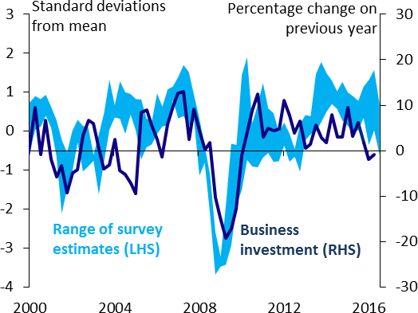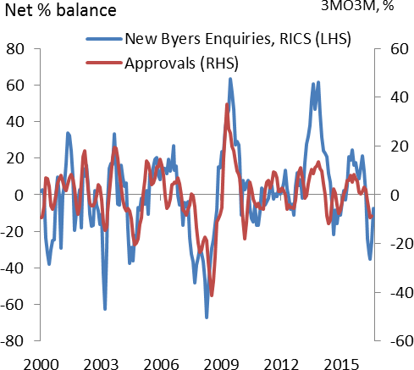But if I had to pick out three possible candidates, one would be the underlying momentum in domestic demand, which now looks to have been stronger than we thought at the time. Another could be the speed with which sterling’s depreciation, and the more general easing in financial conditions, have supported the economy. The foreign exchange market attempts to price long-run risk and, to my mind, the currency fell

after the referendum for fear of what the result might ultimately mean for the UK’s access to global markets. But if that is a risk for the longer term, once the UK’s new trading arrangements come into force, those arrangements are for the time being unchanged. Against that backdrop, the fall in the exchange rate will help to support activity, cushioning the impact of greater uncertainty. While that was expected, the effect could be coming through faster than we’d anticipated. Finally, the near-term impact on housing activity may be more moderate than we feared (Chart 15). Because it’s a highly durable asset, investment in housing should in principle be subject to the same swings in uncertainty that affect business spending. But housing activity is in general well correlated with consumption, which is holding up better. And as a purely non-traded good, housing isn’t affected as directly as business capital by the prospective changes in the UK’s terms of trade. So any impact of greater uncertainty may on this occasion take longer to come through.

But I fear I’m already straying into the temptation I’ve warned against, to over-interpret incoming data. The wiser course is to wait for the November *Inflation Report*, which gives us a good opportunity to reflect more systematically on the news since August, and what it implies – if anything – for the medium-term outlook.

Thank you.

**References**

**Bank of England**, 2016, August 2016 *Inflation Report*, <http://www.bankofengland.co.uk/publications/Documents/inflationreport/2016/aug.pdf>

**Bank of England**, 2012, “The distributional effects of asset purchases”, Quarterly Bulletin, 2012 Q3, <http://www.bankofengland.co.uk/publications/Documents/quarterlybulletin/qb1203.pdf>

**Bean, C.**, 2012, “Pension funds and quantitative easing”, speech given to the National Association of Pension Funds’ Local Authority Conference, <http://www.bankofengland.co.uk/archive/Documents/historicpubs/speeches/2012/speech573.pdf>

**Bernanke, B.**, 2015, “Why are interest rates so low?”, Brookings, [https://www.brookings.edu/blog/ben-](https://www.brookings.edu/blog/ben-bernanke/2015/03/30/why-are-interest-rates-so-low/) [bernanke/2015/03/30/why-are-interest-rates-so-low/](https://www.brookings.edu/blog/ben-bernanke/2015/03/30/why-are-interest-rates-so-low/)

**Bloom, N.,** 2009, ‘The impact of uncertainty shocks’, *Econometrica*

**Broadbent, B., 2013,** ‘Forecast errors’, Speech given at The Mile End Group of Queen Mary, University of London

**Broadbent, B., 2014**, “Monetary policy, asset prices and distribution”, speech given at the Society of Business Economists Annual Conference, <http://www.bankofengland.co.uk/publications/Documents/speeches/2014/speech770.pdf>

**Dixit, A. and R.S. Pindyck**, 1994, “Investment Under Uncertainty”, Princeton University Press

**Haddow, A., C. Hare, J. Hooley and T. Shakir,** 2013, ‘Macroeconomic uncertainty: what is it, how can we measure it and why does it matter?’, *Bank of England Quarterly Bulletin.*

**King, M. and D. Low**, 2014, “Measuring the “world” interest rate”, NBER Working Paper 19887, <http://www.nber.org/papers/w19887.pdf>

**Miles, D.**, 2014, “The transition to new normal for monetary policy”, Speech given at Mile End Group, Queen Mary College, <http://www.bankofengland.co.uk/publications/Documents/speeches/2014/speech707.pdf>

**Park, W.**, 1993, ‘Marriage and divorce: value of waiting’ *The American University, mimeo*

**Rachel, L. and T. Smith**, 2015, “Secular drivers of the global real interest rate”, Bank of England Working Paper No. 571, <http://www.bankofengland.co.uk/research/Documents/workingpapers/2015/swp571.pdf>